Nest Box Use and Nesting Productivity of House Wrens (Troglodytes aedon)
in the Beaverhill Natural Area

By: Melissa Ghadially

August 30, 2018

Introduction
The Beaverhill Natural Area is located in central Alberta, 60 km east from Edmonton, just outside of Tofield. The natural area is an internationally recognized Important Bird Area, with over 270 species reported in the area, over half of which breed locally (About BBO… [accessed 2018]). It is not only used for research but is also open to the public and used for education and recreation (About BBO… [accessed 2018]). The natural area was established on the shores of Beaverhill Lake, which has been dry since 2005. This area consists of aspen forest, grassland, mud flats, and marsh area, making it a perfect habitat for shorebirds and waterfowl (Beaverhill Lake… [accessed 2018])
The Beaverhill Bird Observatory (BBO) was established in 1984 and is the second oldest monitoring station for migratory birds in Canada (About BBO… [accessed 2018]). In 1986 the BBO laboratory was constructed and bunkhouses for staff were later built (History… [accessed 2018]). The observatory is run by a team of staff, volunteers, and summer students, who band birds and conduct bird surveys in the natural area (History… [accessed 2018]). This data is used to track long term changes in populations, migratory patterns, and breeding success in the birds found within the area (About BBO… [accessed 2018]).
House Wrens (Troglodytes aedon) are a small, brown, migratory bird found in a wide range of habitats from Canada to South America (IUCN, 2017). These small birds are 11 to 13 cm long and weigh only 10 to 12 grams (Montana Field Guide, 2018). The preferred habitat of House Wrens is open, shrubby, wooded areas often close to water (Montana Field Guide, 2018). They prefer to nest in sparse vegetation to reduce the risk of predation and intraspecific competition (Belles-Isles & Picman, 1986; Finch, 1989). These wrens are obligatory secondary cavity nesters, but have a preference to man-made nest boxes (Montana Field Guide, 2018).
Male House Wrens build multiple nests in their territory for a female to choose from (Finch, 1989). House Wrens with access to a larger number of closely spaced nest boxes have an increased occurrence of multi-cavity territories, which is not as readily seen in natural cavity dwelling wren populations due to the lack of appropriate natural nesting sites available (Dubois et al., 2006). Therefore, the success of wrens breeding in man-made nest boxes is considerably higher than those that breed in natural cavities (Kaluthota & Rendall, 2017). House Wrens preference for breeding in nest boxes makes them an easy subject to study.
The research for this study was conducted in the Beaverhill Natural Area, through the BBO, as an internship during the breeding season of May to August 2018. Four nest box grids were monitored to determine the success of the House Wren breeding season. In this study I will compared the number of nests constructed by House Wrens in each grid, the number of nests with eggs and the number of nests with hatchlings to determine the productivity of this population of House Wrens.

Methods
Within the Beaverhill Natural Area there are 4 grids, labeled A to D, containing a total of 99 nest boxes for House Wrens (Figure 1) (Cicon, uknown date). The grids were constructed at different time, with Grid A and B established in 2013 and Grids C and D established in 2014 and 2015. Each grid has 25 nest boxes set up in a 5 by 5 grid, except Grid B, which has 24 boxes in a 3 by 8 grid. The nest boxes were checked once a week by myself and another intern (Christine Duke) from May 20 to July 29, 2018.
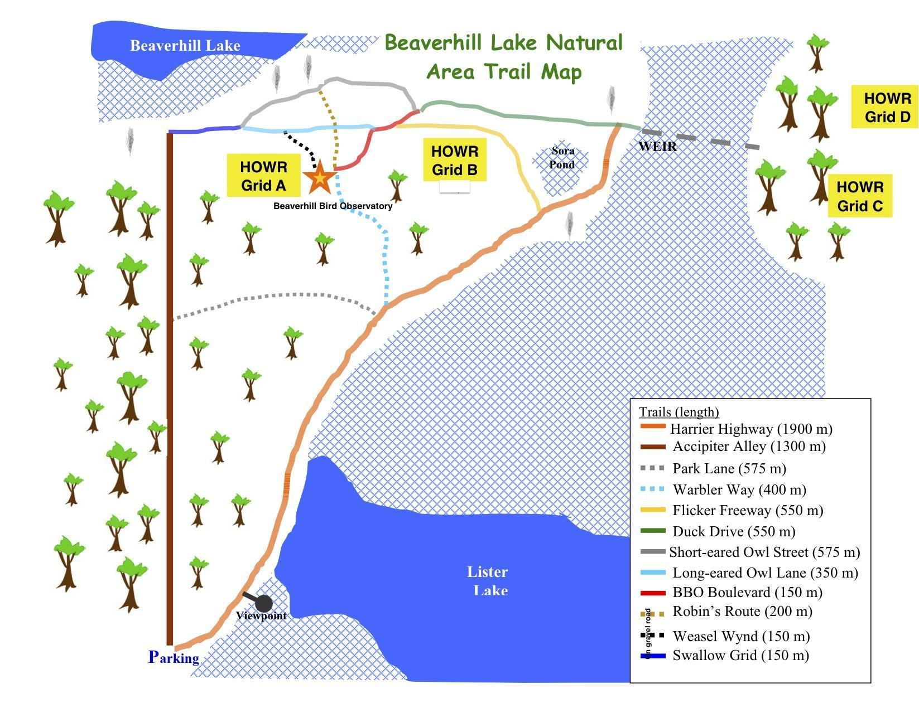
Figure 1. Map of Beaverhill Natural area showing the locations of each House Wren nest box grid.

Every nest box was checked weekly and the species present, nest state (being constructed or complete), number and temperature of eggs (warm or cold), number and age of hatchlings, parents presence, and any other additional notes were recorded. The age of the hatchlings was determined by using Brown’s nestling photo guide (2013). Once there were hatchlings present in the nest boxes they were aged and then not checked again for at least 3 weeks to reduce the chances of early fledging.
The data from previous years (2013, 2014, 2015, 2017) were compiled with this year’s data. Data from 2016 is missing from the BBO records. For each year in each grid, the total number of House Wren nests, nests with eggs, and nests with hatchlings were determined and compared. To determine if there was a significant difference between the number of nests built and the number of nests used to lay eggs a paired t-test was used. To determine if there was a significant difference between the number of nests with eggs laid in them and the number of nests with successfully hatched eggs a paired t-test was used.

Results
Of the 99 nest boxes monitored in 2018, House Wrens built 35 nests in nest boxes. Of the 35 nests, 18 were used to lay eggs and of those 17 nests had successfully hatched eggs. A total for the number of nest boxes used in each grid for each year can be seen in Table 1. For all 5 years combined, 51% of all nest boxes, contained House Wren nests. Out of the nests built by House Wrens, 60% were used to lay eggs and 46% had hatchlings. When comparing all 5 years it was found that there was a statistically significant difference between the number of nests built and the number used to lay eggs (p=0, st dev=3.1). There was also a statistically significant difference between the number of nests containing eggs and the number of nests with hatchlings (p=0.01, st dev=2.53).

Table 1. Total number of House Wren nests, nests with eggs, and nests with hatchlings from all grids from 2013-2018 (2016 excluded).

Grid and year | Number of Nests | Number of Nests with Eggs | Number of Hatchlings
Grid A, 2013 | 19 | 9 | 9
Grid B, 2013 | 12 | 6 | 6
Grid A, 2014 | 11 | 5 | 5
Gtrid B, 2014 | 17 | 13 | 8
Grid C, 2014 | 17 | 9 | 8
Grid A, 2015 | 8 | 7 | 5
Grid B, 2015 | 15 | 9 | 8
Grid C, 2015 | 17 | 13 | 11
Grid D, 2015 | 9 | 5 | 4
Grid A, 2017 | 12 | 9 | 6
Grid B, 2017 | 5 | 4 | 2
Grid C, 2017 | 19 | 15 | 5
Grid D, 2017 | 18 | 7 | 4
Grid A, 2018 | 6 | 5 | 5
Grid B, 2018 | 4 | 2 | 2
Grid C, 2018 | 13 | 8 | 7
Grid D, 2018 | 12 | 3 | 3
Averages | 12.58823529 | 7.588235294 | 5.764705882

Discussion
In this study it was determined that there was a statistically significant difference between the number of nests House Wrens had built and the number of those nests being utilized by females for egg laying. House Wrens are known to create additional dummy nests in their territories (Finch, 1989). The use of dummy nests could explain why there were a statistically significantly higher number of constructed nests compared to those actually being used by females. Dummy nests are built because they can help protect the real nest from predators, since predation is the major cause of nestling failure (Finch, 1989). In the study by Finch (1989) it was noted that females will choose a male with a higher number of dummy nests in order to allow her to easily access a new nest if her first nesting attempt fails. However, there was a later study done by Eckerle & Thompson (2006) to refute the claim of nest building behaviour being an attribute females use to select a mate. Further evidence should be collected on female mate choice to determine if the number of dummy nests is indeed a trait females use to choose a mate.
We found that House Wrens had built nests in an average of 51% of nest boxes but only half of the nests constructed were used to lay eggs. Male House Wrens will defend up to 25% of the available nest boxes in their territory, most of which are in preferred habitats (Eckerle & Thompson, 2006). The nest boxes were only surveyed once a week so we did not observe any males territorial behaviour. The size of a male’s territory and the number of nest boxes he builds in and defends would be important to know to determine what percent of nest boxes in his territory he is defending and how many mates he is attracting.
During this study some lids to the nest boxes were found removed. This may have been a result of strong winds or predation. The lids were fixed to the boxes using wires wrapped around screws on each side therefore wind is not likely the cause for all of the displaced lids. Predation is a likely cause of the loss of some of the eggs and hatchlings. During the study there was no definitive evidence observed on or around any of the nest boxes, such as broken eggs, to indicate predation but that is no doubt a cause of some mortality due to the presence of predatory birds such as ravens and raptors.
The comparison between the number of House Wren nests used to lay eggs to the number of nests with hatchlings resulted in a statistically significant difference between the two. This indicates a significant mortality rate of House Wrens eggs in this study. The number of eggs that did not hatch in each nest was not taken into account due to challenges of being unable to survey the young once chicks had hatched in order to avoid early fledgling. The mortality of eggs may be a result of egg destruction by other House Wrens in an attempt to secure the surrounding resources for themselves (Quinn & Holroyd, 1989), or predation (Finch, 1989).

Conclusion
This study showed a significant number of House Wren nests being unused for egg laying and a significant number of clutches lost before hatching. The unused nests are most likely due to the extra dummy nest building behavour of the wrens and the losses are likely the result of predation and competition between wrens. More study is need to determine how the size of male wrens’ territories impacts their reproductive success, and if there are any other limiting factors to nesting success of House Wrens in the Beaverhill Natural Area.

References

Beaverhill Bird Observatory. [date unknown]. Tofield (AB): About BBO; [accessed 2018 Aug 9]. http://beaverhillbirds.com/welcome/about-bbo/

Beaverhill Bird Observatory. [date unknown]. Tofield (AB); History. [accessed 2018 August 9]. http://beaverhillbirds.com/welcome/history/

Beaverhill Bird Observatory [date unknown]. Tofield (AB); Beaverhill Lake. [accessed 2018 August 9]. http://beaverhillbirds.com/welcome/beaverhill-lake/

Belles-Isles J, Picman, J. 1986. Nesting losses and nest site preferences in house wrens. The
Condor. 88(4):483-486.

Brown WP, Zuefle ME, Underwood TJ, Alexander AL, Alexander DA. 2013. House Wren Nestling Age Can Be Determined Accurately From a Guide of Digital Images. North American Bird Bander. 38:150-159.

Cicon E. [date unknown]. House Wren Internship. Beaverhill Bird Observatory Internship Information Packet. Tofield (AB): Beaverhill Bird Observatory.

Dubois NS, Kennedy ED, Getty T. 2006. Surplus nest boxes and the potential for polygyny affect clutch size and offspring sex ratio in house wrens. Royal Society. 273:1751- 1757.

Eckerle KP, Thompson CF. 2006. Mate choice in house wrens: nest cavities trump male characteristics. Behaviour 143:253-271.

Finch DM. 1989. Relationships of surrounding riparian habitat to nest-box use and reproductive outcome in House Wrens. The Condor. 91:848-859.

Kaluthota CD,Rendall D. 2017. Nest site selection and breeding biology of Western House Wrens (Troglodytes aedon parkmanii) using natural cavities in Western Canada. Canadian Journal of Zoology. 95: 505-514.

Quinn M, Holroyd G. 1989. Nestling and egg destruction by house wrens. The Condor. 91(1), 206-207.

