Acoustic Monitoring of Insectivorous Bats in Various Habitat Types at the Beaverhill Natural Area Using Ultrasonic Detectors at Three Different Frequencies
Authors: Véronique Caron and Jenna Hlewka
Internship Mentor: Lynne Burns
Beaverhill Natural Area, Tofield, Alberta
June 7th - September 19th, 2018

Table of Contents
Introduction………………………………………………………………………………..2
Methods……………………………………………………………………………………6
Results………………………………………………………………………………..…..10
Discussion………………………………………………………………………………..12
Conclusion……………………………………………………………………………….15
Recommendations for Future Studies……………………………………………………15
Acknowledgements………………………………………………………………………16
References………………………………………………………………………………..17
Appendices……………………………………………………………………………….21

Introduction
Bats are often misunderstood by the public as pests or dangerous creatures while, in fact, they are fascinating and important contributors to our ecosystems (Kunz, et al., 2011). Among their many interesting characteristics, they possess the ability to navigate through their habitats, locate prey, and communicate with other bats through a technique called echolocation (Fenton & Barclay, 1980). Although bats aren’t the only mammals with this ability, the complexity and design of their echolocation calls is unique. In echolocation, calls are emitted by microbats through laryngeal muscle contractions. Calls bounce off encountered objects and are received by the pinna of the outer ear and the tragus, which is an elongated prominence on the inner side of the external ear (Fenton & Barclay, 1980). In using echolocation, bats sense their environment through sound which is advantageous since they are nocturnal.

There is great variation in echolocation frequencies and call structures among the many bat species. Bats from a given species can use various frequencies in their echolocation call depending upon the purpose of their call; clutter, distance and type of call (e.g., searching or actively pursuing prey) can all contribute to frequency and shape variation (Patriquin, et al., 2003). The average range for insectivorous bats can ranges generally between 20 kHz and 60 kHz (Fenton, et al., 1998). Additionally, these frequencies are species, or species group -specific, thus allowing researchers to identify various bat species, or species groups based on the echolocation frequency emitted. The emission of these frequencies between similar species provides these mammals with the ability to communicate intra- and interspecifically, thus providing the opportunity for higher foraging efficiency (Jones & Holderied, 2007). Effective foraging is not just a result of intraspecific communication, it is also dependent on the specific characteristics of the given species echolocation call, as well as the habitat the species is foraging in. An echolocation call can be emitted in different ways and different lengths depending on the habitat the bat is in, or simply just based on the purpose of emission (searching or approaching). A narrow-band call is a longer call with extended call intervals, whereas a broadband call is a shorter call with reduced call intervals (Jacobs & Bastian, 2016). A study showed that narrow band calls at lower frequencies are more suitable for detection of prey that is further away, but it had a higher chance of being altered by acoustic disarray; on the other hand, the acoustic disarray was seen to not affect broadband calls at higher frequencies (Simmons & Stein, 1980, as cited in Aldridge, & Rautenbach, 1987).

Habitat selection varies between different species of bats based upon their specific requirements and preferences. Selection of habitat is based upon whether or not the area can adequately sustain the species by providing the specific resources that bats need such as roosting and foraging opportunities. This can be affected by several extrinsic factors which include: vegetation, anthropogenic impacts, land use, and land morphology (Threlfall, et al., 2012, as cited in Ciechanowski, 2015). The ability to echolocate allows bats to orient themselves within the habitat, as well as successfully forage at night due to their nocturnal habits. Within the genus Myotis, bats commonly found in Alberta, foraging styles vary based upon each Myotis species and its specific morphology. Foraging can be accomplished through several different approaches such as aerial feeding, feeding over water, trawling, and gleaning (Fenton & Bogdanowicz, 2002). Each Myotis species varies slightly in morphological characteristics (e.g., wing shape which influences maneuverability), therefore, habitat preference can be based upon the species preferred foraging method. Whilst habitat preference and foraging behavior work synergistically, it is often difficult to visually assess the amount of bat habitat use due to their nocturnal feeding characteristics (Vaughan, et al., 1997). This is why acoustic monitoring of bats through the use of echolocation detectors is so important in order to become more knowledgeable on bat foraging activity.

Echolocation detectors are critical for bat acoustic monitoring because the acoustical frequencies emitted from these mammals are ultrasonic and therefore outside of the human audible range. The average human is capable of detecting sounds with frequencies anywhere between 20 Hz and 20,000 Hz (20 kHz) (Wereski, 2015). Most Alberta bat call frequencies are above 20 kHz (Alberta Bat Community Program, 2018), so without echolocation detectors, acoustic monitoring of bats would be impossible. While echolocation has been documented to assist bats in spatial awareness and foraging, it has also been hypothesized to have the ability to allow social communication between individuals (Knörnschild, et al., 2012). Social communication through the use of echolocation is still largely unknown. There are few studies documenting its use because it is complicated by the fact that echolocation frequencies are not emitted solely for the purpose of conversation, rather they are emitted to inform the individual of presence or absence of obstacles and prey (Knörnschild et al., 2012).

There are several roles that bats play within ecosystems that not only benefit the ecosystem itself but also have a positive role in the economics of the agriculture industry. The economic importance of bats in relation to the agricultural industry has been slowly gaining conservation interest due to the fact that this mammalian group’s reputation tends to be misconceived in the public eye (Kunz et al, 2011). It has been estimated that insectivorous bats, specifically the Little Brown Bat (Myotis lucifugus), at peak lactation can consume over 100% of its body weight in insects at night (Kunz et al., 2011). Their immense consumption of insects makes these species such an important part of the control of crop infestation by herbivorous insect pests (Riccucci & Lanza, 2014). Due to the ability of the bats to control the infestation of crop pests, this can in turn boost economic profits within the agricultural industry. Many North American insectivorous bats feed largely on moths and beetles, which can be detrimental to crops in their larval forms and cause substantial loss (Eco-Farming, 2017). Additionally, agricultural pests eaten by bats include: spotted cucumber beetles, brown stink bugs, and several cutworms (Eco-Framing, 2017). When looking at these species from a purely economic standpoint, their contribution can range anywhere from $3.7 Billion to $53 Billion per year due to reduced pesticide usage (Boyles, et al., 2011). Sadly, these numbers, along with bat population numbers have been steadily decreasing due to an introduced pathogenic fungus, Pseudogymnoascus destructans, more commonly known as White Nose Syndrome (WNS). When looking at the decline in bat populations that are caused by WNS in relation to the species agricultural impacts, it is estimated that approximately 660 to 1320 metric tons of insects per year will not be consumed (Boyles et al., 2011).

Bat acoustic monitoring at the Beaverhill Natural Area (BNA) is important to determine which species reside in the area, which species are most prevalent, and which species may have lower abundance. Monitoring bat activity allows researchers to measure the health of the environment, due to bats being indicators of biodiversity (Bat Conservation Trust, 2018b). They are also important pollinators and play a major role in reforestation in some tropical areas (Bat Conservation Trust, 2018b). Moreover, fructivorous bats play a large role in pollination and seed dispersal of plants. Chiropterophily, also known as bat pollination, is relied on by over 500 different species of plants (Bat Conservation Trust, 2018b). Through the process of Chiropterophily, bats also play a role in seed dispersal by obtaining seeds whilst feeding and dropping them during commute to other feeding or roosting locations (Bat Conservation Trust, 2018b). As time progresses, and the needs of ecosystems increase, the importance of bats within these systems will be made even more prevalent. Moreover, monitoring bat activity within the BNA is essential to determine ecosystem health and overall suitability and also plays a role in determining bat population success in the area. Since bats are such an important component of the food chain, it is important to increase their chances of survival in the area by monitoring their occupancy and by determining which species are present in the area and what contributes to their survivorship.

The purpose of our study is to acoustically monitor bat activity at three different frequencies within three different habitat types within the BNA. Monitoring of bat activity at three different frequencies (25 kHz, 30 kHz, and 40 kHz) is being conducted due to the fact that the expected species within the BNA are grouped into these three frequency groups. As well, three different habitats (grassland, forested, and riparian) were selected based upon bat foraging activity. The grassland habitat provides the bats with open foraging grounds, while the forested habitat provides more clutter for foraging since the surrounding foliage attracts numerous insects, and lastly, the riparian habitat provides bats with an area for rehydration whilst acting as a large congregation area for flying insects (Bat Conservation Trust, 2018a).We hypothesize that bat acoustic activity will be the greatest in open areas, such as the grassland or riparian habitats, due to the Myotis species’ association with foraging mostly in open and edge habitats (Furlonger, et al., 1987); it would be fair to make this premise since BNA’s bat population predominantly consists of Myotis sp. We also estimate that acoustic activity will be the greatest with Myotis sp. when compared to larger-bodied bat species, such as the Big Brown Bat (Eptesicus fuscus; EPFU) and the Silver-haired Bat (Lasionycteris noctivagans; LANO) based on last year’s bat acoustics monitoring report findings at BNA, written by Emily Gillmore (Gillmore, 2017).

Methods
Study area
The Beaverhill Bird Observatory (BBO) is located within the BNA near Tofield, Alberta. The area consists of forested, riparian, and grassland habitats, dominated by trembling aspen (Populus tremuloides), willow (Salix sp.), grasses, rushes, and balsam poplar (Populus balsamifera). The natural area is only accessible by foot; ATVs and vehicles are not permitted within the BNA boundaries for conservation purposes.

Transects
To monitor bat acoustic activity in the area, monitoring stations were placed along two 300 and one 500 meter transect, each at intervals of 100 meters. The grassland and riparian transect were 300 meters long, consisting of three stations; while the forested transect was 500 meters long and consisted of five stations (Figure 1). We chose to add two additional stations on the forested transect due to increased bat activity and dependence associated within forested habitats (Alberta Fish and Wildlife, 2002). The riparian transect is located on a grassy path crossing the weir, thus the stations are not located directly in the water (Figure 1). Each station was flagged with labelled blue flagging tape (Figure 2). The flagging tape was labelled “R” for the riparian transect, “F” for the forested transect, and “G” for the grassland transect, along with the corresponding station number. The UTMs for each station were recorded onto a data sheet in datum NAD 83, using a Garmin GPS unit (Appendix C).

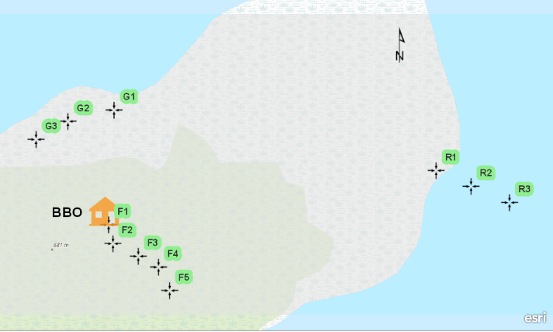
Figure 1. Map generated from ArcGIS depicting the three acoustic transects and stations used for acoustic monitoring at the BNA (V. Caron 2018).

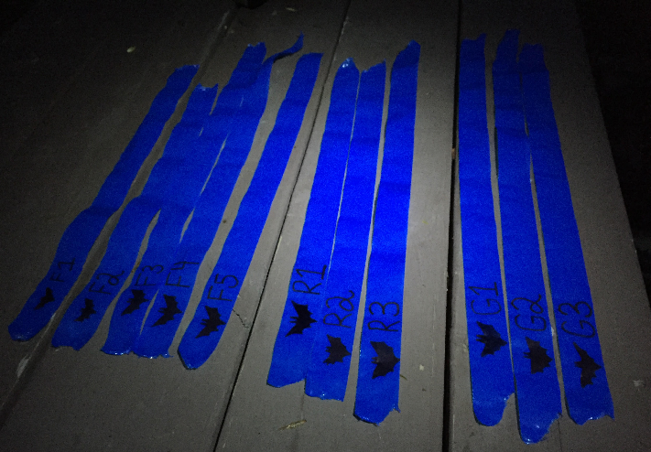
Figure 2. The flagging tape used to mark each echolocation monitoring station within the forested (left), riparian (middle), and grassland (right) habitat transects. (V. Caron, 2018).

Acoustic Monitoring
Bat acoustic activity was monitored on a weekly basis and began fifteen minutes after sunset. A survey would consist of setting a mini bat detector, made by QMC instruments Ltd. (Figure 3), at three different frequencies: 25 kHz, 30 kHz, and 40 kHz respectively for two minutes each while listening closely for detections; thus, one frequency survey would be six minutes long. The QMC detector also contained a table on the acoustical identification of bats on the back of the detector, placed by a previous user (Table 1; originally from Fenton et al. 1983, Holroyd 1983). A detection would be recorded as either a “passing buzz” or a “feeding buzz”; a passing buzz is shorter and sounds like a tonal chirp or jingle, while a feeding buzz is longer and sounds similar to passing a finger on a comb (Nature Canada, 2018). When a detection occurred, it was recorded on the data sheet under the respected frequency and transect (Appendix B). It should be noted that on the third week of July, acoustic monitoring did not occur due to a severe thunderstorm warning for the Tofield area; acoustic monitoring also did not occur on the second week of September due to an unexpected snowfall.

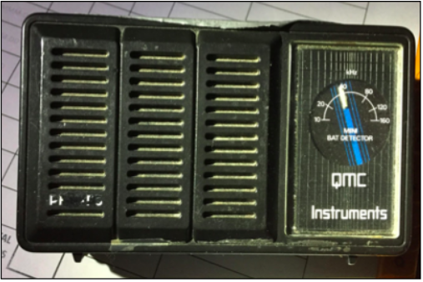
Figure 3. An image of one of the QMC bat acoustic detectors used throughout the project. (V. Caron, 2018).

Table 1. The acoustical identification of bats based on sound characteristics. Adopted from the “Identification of Bats using the QMC Bat Detectors”, a table that was located on the back of one of the detectors supplied by Geoff Holroyd originally from Fenton et al. 1983, Holroyd 1983.
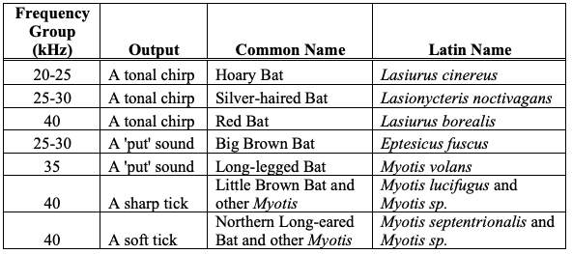

Statistical Analysis
In order to directly compare our data to the 2017 survey, we conducted an identical statistical analysis as seen in Gillmore's acoustic monitoring report (Gillmore, 2017). This entailed conducting two Chi-Square Tests for Homogeneity manually in order to determine the difference in bat acoustic detections between the three habitat types and the three echolocation frequencies.

Results
Over fifteen weeks of study, a total of twenty detections were recorded; unfortunately, during week one, two, six, seven, nine, eleven, twelve, and fifteen, there were no acoustic detections recorded on the weekly surveys (Figure 4). The highest amount of bat acoustic activity was located at the forested transect with a total of nine detections (45%), whilst the grassland habitat had the least amount of detections recorded with a total of three detections (15%); additionally, the riparian habitat had a total of eight recorded detections (40%) (Figure 5). The station with the highest amount of detections was R1 with seven, and the stations with the fewest detections were R2, G2, and G3 with no recorded detections. Our data consisted only of passing buzzes as there were no feeding buzzes detected with the QMC Mini Bat Detector in all habitat types. Per frequency group, the highest amount of detections occurred at the 25 kHz frequency (ten; 50%), followed by 30 kHz (seven; 35%), and then the lowest acoustic activity was recorded at the 40 kHz frequency (three; 15%) (Figure 6).

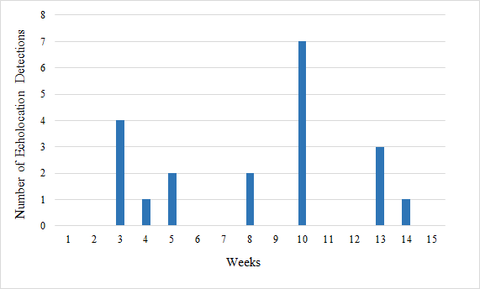
Figure 4. The number of acoustic detections recorded with a QMC Mini Bat Detector at frequencies of 25, 30, and 40 kHz in three different habitat types over the course of fifteen weeks from June 7th to September 19th, 2018

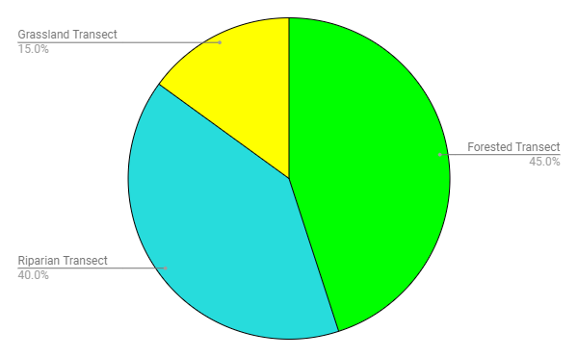

Figure 5. The number of acoustic detections recorded with a QMC Mini Bat Detector at three different habitat types (forested, riparian, and grassland) over the course of fifteen weeks from June 7th to September 19th, 2018
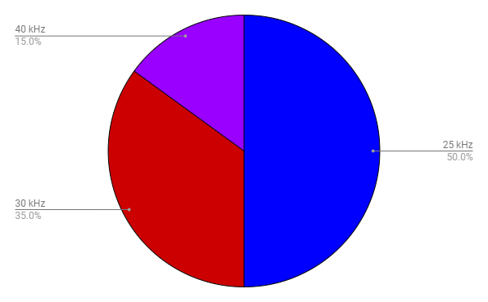

Figure 6. The number and percentages of acoustic detections recorded with a QMC Mini Bat Detector at frequencies of 25, 30, and 40 kHz over the course of fifteen weeks from June 7th to September 19th, 2018

From the Chi-Square Tests for Homogeneity, our null hypothesis is that there is no significant difference in the observed frequency distribution of the three habitat types and the three echolocation frequencies. Our alternate hypothesis is that there is a significant difference in the observed frequency distribution of the three habitat types and the three echolocation frequencies. The Chi-Square value (0.8256) for the three different habitat types was less than the Chi-Square Distribution Table value for both the 0.05 and 0.01 level of significance (5.99 and 9.21 respectively) thus, we failed to reject the null hypothesis and no further statistical analysis is required. In addition, the Chi-Square value for the three different echolocation frequencies (0.5552) was less than the Chi-Square Distribution Table values (5.99 and 9.21), thus we failed to reject the null hypothesis and no further statistical analysis is required.

Discussion
Analysis of the acoustic data showed that there is no significant difference in the frequency distribution of detections between the three different habitat types and the three different echolocation frequencies. Based upon the frequency groups in Table 1, the species that could have been detected based upon our results are: The Hoary Bat (25 kHz), Silver-haired Bat and Big Brown Bat (25-30 kHz), and the Red Bat, Little Brown Bat, and Northern Long-eared Bat (40 kHz). Overall there were few acoustic detections which resulted in a low sample size which likely impacted our ability to detect any differences among the habitat types. Limited variance between the frequency distribution of detections could be attributed to several factors.
A factor contributing to the low number of detections during this monitoring period could be the dated ultrasonic detectors, the QMC Mini Bat Detector, used throughout the study. The detection window of the QMC Mini Bat Detector is only viable within 3 kHz above or below the selected frequency (Thomas and West, 1984). This narrow range allows for precise detection at the selected frequency but, does not allow for the detection of more than one frequency at one time (Thomas and West, 1984). The inability to scan for more than one frequency at a given transect point could have resulted in missed detections of other frequencies due to them not being selected. Another factor that could have contributed to our low number of detections could have been an inaccuracy in frequency selection. The slightest offset of the dial on the selected frequency could potentially result in missed calls due to the narrow 3 kHz window. The precision with which the detector is tuned has an overall effect on the detection ability of the QMC Mini Bat Detector (Thomas and West, 1984). Variability between individual units can also result in decreased detection accuracy. In a study done by Thomas and West (1994), six QMC Mini Bat Detectors were used. After their study, they determined that there were differences in the detection accuracy of each unit (Thomas and West, 1994). Throughout our study, we used a total of three different QMC Mini Bat Detectors due to one with a broken dial and another with reduced volume output. This could have contributed to the accuracy of our detections due to the fact that multiple detectors were used. Additionally, it should be noted that during one of our surveys, the detector picked up the movements of a nearby flying squirrel. The output from the detector that resulted from the flying squirrel was similar in sound to an echolocation output; this could also affect the validity of the acoustic data. Since ultrasonic detectors are only supposed to capture the sounds of frequencies too high for the human ear (Wereski, 2015), it was concerning that it would pick up the sounds of a nearby squirrel, which could be heard with the naked ear.
An additional factor that could have resulted in decreased detections could be attributed to the suspected absence of a maternity colony on site (Low, 2017). This is due to the fact that maternity colonies are affiliated with increased numbers as they are areas in which gestating females roost in close proximity to rear their young (Bat Conservation Trust, 2019). If this is the case, our detections may have mainly been of male resident bats that are generally solitary.
Another important variable that must be considered when analyzing our data is the time of day at which the echolocation monitoring was initiated. Our echolocation data was collected approximately fifteen minutes after sunset once a week; however, this time of day might not be ideal for peak bat activity. In a study conducted by Agosta et al. (2005), the researchers determined that bats were not seen emerging from their roosts until three to five hours after sunset, and that there was very little bat activity during the first hour after sunset (Agosta, et. al., 2005). This could have contributed to the low number of detections collected throughout the survey period. Another study conducted by Rydell, et al. (1996) suggests that insectivorous bats also emerge from their roosts according to their food source. They determined that bat species that feed on moths emerge from their roosts later in the evening compared to Diptera-feeding bats, and that larger bats emerged from their roosts earlier in the evening than smaller bats. This could have contributed to the low number of detections recorded during the study period, due to our target species being microbats, thus, theoretically emerging from roosts later in the evening. Overall, the time of day at which the monitoring was initiated could have affected our poor results by many variables, such as food source, time, and size.

Lastly, another important variable to consider when collecting the data is that it was limited to three transects. All of which were located along man-made trails and paths around the BNA; this could also impact our detections as these might not be the ideal locations for peak bat foraging and acoustic activity. According to a study conducted by Jantzen and Fenton (2013), Myotis lucifugus, Eptesicus fuscus, and Lasionycteris noctivagans were more active within twenty meters of the forest edge, and closer to water bodies. This would explain why most of the detections were recorded in the forested and riparian transects, as all Alberta bat species, excluding Myotis ciliolabrum, rely on forested habitats (Alberta Fish and Wildlife, 2002). Since the grassland transect was distanced from the forest edge and in the middle of an open field, that could have contributed to the low number of detections in that transect, as bats typically strive near forest edges (Jantzen & Fenton, 2013).

Conclusion
Over a monitoring season of fifteen weeks, our results show that most acoustic activity occurred in the forested habitat, as opposed to riparian and grassland, and most of the detections were of 25 kHz frequency. Overall, acoustic activity was very low throughout the monitoring season; this could have been due to dated and variable ultrasonic detectors, the time of day at which the surveys were conducted, or other extrinsic factors such as the location of the transects in relation to peak bat forage activity and roost emergence. The results of the statistical analysis determined that there was no difference in the frequency of detections between habitat types and echolocation frequencies.

Recommendations for Future Studies
The detectors used were dated and difficult to interpret, thus allowing for a wide range of variability in the results obtained; future studies should consider the use of a newer, more accurate ultrasonic detector. For subsequent studies, we would also recommend the use of only one detector to ensure consistency in data collection. Additionally, acoustic monitoring should begin an hour after sunset to ensure that it is conducted after roost emergence and during peak foraging activity. Another suggestion would be to establish the grassland transect closer to the forest edge instead of in the middle of a field; it could potentially increase the number of detections in that transect, since our data sets were very limited for that habitat type.

Acknowledgements
We would like to thank the BBO staff for providing us with the opportunity to be a part of this wonderful project. We would also like to give thanks to Geoff Holroyd and Laurie Hunt for organizing the internship, as well as the Serving Communities Internship Program (SCiP) and the Fort Saskatchewan Naturalist Society for the funding towards our project. We are so grateful for all the support and help we have had from our project mentor, Lynne Burns; thank you for helping with everything we needed throughout our project, it was a privilege to be mentored by you. We would also like to thank Ken and Laurie Hlewka for providing us their vehicles for travelling to the field site every week. Also, we would like to give thanks to Emmanuel Mapfumo for his insight on our statistical analysis. Lastly, we would also like to thank Dave Critchley for supporting us throughout our project and for answering any additional questions.

References
Agosta, S. J., Morton D., Marsh, B. D., & Kuhn, K. M. (2005). Nightly, seasonal, and yearly patterns of bat activity at night roosts in the central Appalachians. Journal of Mammalogy, 86(6), p. 1210-1219.
Alberta Bat Community Program (2018). Building bat-friendly Communities: Alberta program guide. Retrieved from: http://www.albertabats.ca/resources/
Alberta Fish and Wildlife (2002). Handbook of inventory methods of standard protocols for surveying bats in Alberta. Retrieved from: https://open.alberta.ca/publications/4795089
Aldridge H. D. J. N., & Rautenbach, I. L. (1987). Morphology, Echolocation and
Resource Partitioning in Insectivorous Bats. Journal of Animal Ecology, 56(3),
763-778. doi:10.2307/4947
Bat Conservation Trust (2018a). Where do bats live?: Bat habitats. Retrieved from:
http://www.bats.org.uk/pages/bat_habitats.html
Bat Conservation Trust (2018b). Why bats matter. Retrieved from:
http://www.bats.org.uk/pages/why_bats_matter.html
Bat Conservation Trust (2019). Bat roosts: Maternity roosts. Retrieved from:
https://www.bats.org.uk/about-bats/where-do-bats-live/bat-roosts/maternity-roosts
Boyles, J., Cryan, P., McCracken, G., & Kunz, T. (2011). Economic Importance of Bats
in Agriculture. Science, 332(6025), 41-42. Retrieved from
http://www.jstor.org.login.ezproxy.library.ualberta.ca/stable/29783965
Ciechanowski, M. (2015). Habitat preferences of bats in anthropogenically altered, mosaic landscapes of northern Poland. European Journal of Wildlife Research, 61(3), 415-428. doi: 10.1007/s10344-015-0911-y
Fenton, M.B., H. G. Merriam, and G. L. Holroyd. 1983. Bats of Kootenay, Glacier, and Mount Revelstoke national parks in Canada: identification by echolocation calls, distribution, and biology. Canadian Journal of Zoology, 1983, 61(11): 2503-2508.
Eco-Farming. (2017). Bats for natural pest control. Retrieved from: http://ecofarmingdaily.com/bats-for-natural-pest-control/
Fenton, M. B., & Barclay, R. (1980). Myotis lucifugus. Mammalian Species, (142), 1-8. doi:10.2307/3503792
Fenton, M. B., Portfors, C. V., Rautenbach, I. L., & Waterman, J. M. (1998). Compromises: Sound frequencies used in echolocation by aerial-feeding bats. Canadian Journal of Zoology, 76(1), 1174-1182. doi:10.1139/cjz-76-6-1174
Fenton, M. B., Bogdanowicz, W. (2002). Relationships between external morphology and foraging behaviour: Bats in the genus myotis. Canadian Journal of Zoology, 80(6), 1004-1013. doi: 10.1139/z02-083
Furlonger, C. L., Dewar, H. J., & Fenton, M. B. (1987). Habitat use by foraging insectivorous bats. Canadian Journal of Zoology, 65(2), p. 284-288. doi: 10.1139/z87-044
Gillmore, E. (2017). Habitat use and spatial patterns of Myotis and large-bodied bat species assessed by the narrow-band acoustic method at the Beaverhill Bird Observatory. Beaverhill Birds. Retrieved from: http://beaverhillbirds.com/publications/student-interns/
Holroyd, G.L. 1983. A brief survey of the bats of Elk Island National Park. Blue Jay 41:217-222.
Jacobs, D.S. & Bastian, A. (2016) Bat echolocation: Adaptations for prey detection and capture (Ed.), Predator–prey interactions: Co-evolution between bats and their prey (pp. 13-30. Cham, Switzerland: Springer Cham.
Jones, G., & Holderied, M. (2007). Bat echolocation calls: Adaptation and convergent evolution. Proceedings: Biological Sciences, 274(1612), 905-912. doi: 10.1098/rspb.2006.0200
Jantzen, M. K., & Fenton, M. B. (2013). The depth of edge influence among insectivorous bats at forest-field interfaces. Canadian Journal of Zoology, 91(5), p. 287-292. doi: 10.1139/cjz-2012-0282
Knörnschild, M., Jung, K., Nagy, M., Metz, M., & Kalko, E. (2012). Bat echolocation calls facilitate social communication. Proceedings: Biological Sciences, 279(1748), 4827-4835. doi: doi: 10.1098/rspb.2012.1995
Kunz, T. H., Braun de Torrez, E., Bauer, D., Lobova, T., & Fleming, T. H. (2011). Ecosystem services provided by bats. The Year in Ecology and Conservation Biology, 1223(1), 1-38. doi: 10.1111/j.1749-6632.2011.06004.x
Low, E. (2017). Occupancy monitoring of bat houses at beaverhill bird observatory in 2017. Beaverhill Birds. Retrieved from: http://beaverhillbirds.com/publications/student-interns/
Nature Canada (2018). Bat sounds – Naturehood bat detector lending library. Retrieved from: http://naturecanada.ca/news/blog/batsounds/
Patriquin, K., Hogberg, L., Chruszcz, B., & Barclay, R. (2003). The influence of habitat structure on the ability to detect ultrasound using bat detectors. Wildlife Society Bulletin, 31(2), 475-481.
Riccucci, M. & Lanza, B. (2014). Bats and insect pest control: A review. Retrieved from: https://www.ceson.org/vespertilio/17/161_169_Riccucci.pdf
Rydell, J., Entwistle, A., & Racey, P. A. (1996). Timing of foraging flights of three species of bats in relation to insect activity and predation risk. Oikos, 76(2), p. 243-252.
Simmons, J. A. & Stein, R. A. (1980). Acoustic imaging in bat sonar: Echolocation signals and the evolution of echolocation. Journal of Comparative Physiology, 135, 61-8. doi: 10.1007/BF00660182
Thomas, D.W. & West, S. D. (1984). On the use of ultrasonic detectors for bat species identification and the calibration of QMC mini bat detectors. Canadian Journal of Zoology, 62(12), 2677-2679. doi: 10.1139/z84-390
Threlfall C. G., Law B., Banks P. B. (2012) Influence of landscape structure and human modifications on insect biomass and bat foraging activity in an urban landscape. PLoS ONE 7(6). doi:10.1371/journal.pone.0038800
Vaughan, N., Jones, G., & Harris, S. (1997). Habitat use by bats (Chiroptera) assessed by means of a broad-band acoustic method. Journal of Applied Ecology, 34(3), 716-730. doi:10.2307/2404918
Wereski, Mike (2015). The threshold of hearing. The STEAM Journal, 2(1). doi:10.5642/steam.20150201.20

Appendix A: Bat Acoustic Count Data Sheet
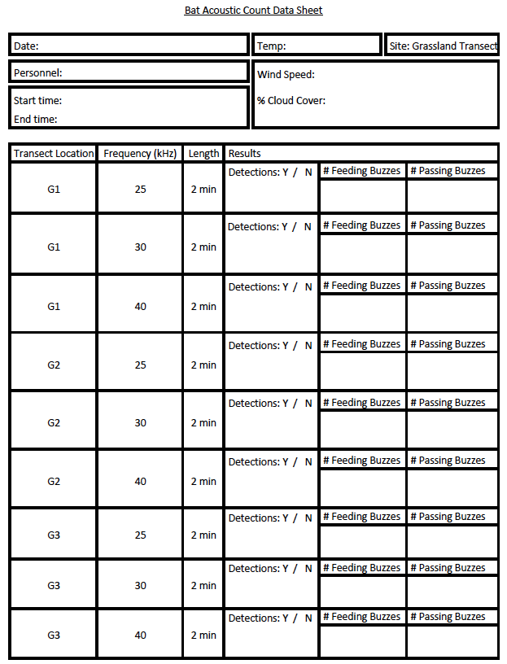
(An example of one of the data sheets used for acoustic monitoring; all three habitat types have their own data sheet, but the layout is identical)
Appendix B: Transect Site Locations from all three habitats
Transect | Transect Point | UTM
 |  | Zone: 12U
 | F1 | Easting: 398411
 |  | Northing: 5915663
 |  | Zone: 12U
 | F2 | Easting: 398421
 |  | Northing: 5915616
 |  | Zone: 12U
FORESTED | F3 | Easting: 398482
 |  | Northing: 5915583
 |  | Zone: 12U
 | F4 | Easting: 398531
 |  | Northing: 5915556
 |  | Zone: 12U
 | F5 | Easting: 398557
 |  | Northing: 5915497
 |  | Zone: 12U
 | G1 | Easting: 398431
 |  | Northing: 5915945
 |  | Zone: 12U
GRASSLAND | G2 | Easting: 398318
 |  | Northing: 5915920
 |  | Zone: 12U
 | G3 | Easting: 398239
 |  | Northing: 5915877
 |  | Zone: 12U
 | R1 | Easting: 399213
 |  | Northing: 5915779
 |  | Zone: 12U
RIPARIAN | R2 | Easting: 399297
 |  | Northing: 5915739
 |  | Zone: 12U
 | R3 | Easting: 399390
 |  | Northing: 5915696
GPS INFORMATION: | Model: Garmin GPSmap 62S | Datum: NAD83
 | Unit ID: 3863382964

