Bat House Occupancy Monitoring at the Beaverhill Natural Area
Authors: Véronique Caron and Jenna Hlewka
Internship Mentor: Erin Low
Beaverhill Natural Area, Tofield, Alberta
May 10th - September 26th, 2018
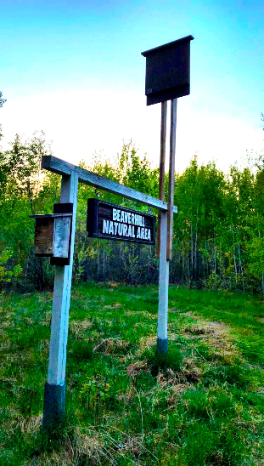
(J. Hlewka, 2018)

Table of Contents

Introduction………………………………………………………………………………..2
Methods…………………………………………………………………………………....6
Results……………………………………………………………………………………11
Discussion………………………………………………………………………………..14
Conclusion……………………………………………………………………………….16
Future Recommendations………………………………………………………………..16
Acknowledgements……………………………………………………………………....17
References………………………………………………………………………………..18
Appendices…………………………………………………………………………….....21

Introduction
The ecological roles of insectivorous bats is essential to preserve ecosystem health (Bat Conservation International, 2018). They contribute to our ecosystems through their immense consumption of agricultural pests. A previous study found that a 7.9 gram Little Brown Myotis (Myotis lucifugus), at peak lactation consumed approximately 9.9 grams of insects in one night (Kunz et al., 2011). This remarkable ability to consume over 100% of their own body weight provides a huge benefit to the agricultural industry by reducing pest infestations on crops and reduce the need for pesticides (Riccucci & Lanka, 2014 and Bat Conservation Trust, 2018). A study conducted in 2011 determined that nightly oviposition of mosquitoes decreased by 32% with the presence of insectivorous Northern Myotis (Myotis septentrionalis) for nine consecutive nights (Kunz et al., 2011). Their economic contribution to the agricultural industry ranges from $3.7 to $53 billion per year, due to the reduction of pesticide applications needed (Boyles et al., 2011).

Although there are no fruit bats in Canada, in other parts of the world bats are important pollinators and seed dispersers (Bat Conservation Trust, 2018). These bat species play a role in reforestation by excreting the seeds of the plants that they consume in different areas (Bat Conservation Trust, 2018). Unfortunately, North American bat populations are currently affected by Pseudogymnoascus destructans, a pathogenic fungus more commonly known as the culprit which causes White Nose Syndrome (WNS). WNS is a white-powdery invasive fungus that accumulates around the wings and nasal region of infected bats (Government of Alberta, 2018). The fungus is transmitted from bat-to-bat due to the social tendencies and congregation patterns of bats prior to and during the over winter period (Neighbourhood Bat Watch, 2018). Sadly, P. destructans thrives within bat hibernacula due to its psychrophilic (cold-thriving) capabilities (Verant et al., 2012). The exact transmission route of WNS is not yet known, but studies have shown that certain roosting colonies’ movement and behavior may lead to vector transmission within summer roosts (Reichard & Kunz, 2009). Although WNS has not been detected in Alberta, the fungus has caused significant mortality of hibernating bats species in other parts of Canada resulting with them being listed as endangered by both the Committee on the Status of Endangered Wildlife in Canada (COSEWIC) and the Species at Risk Act (SARA). The Little Brown Myotis and the Northern Myotis have been listed under COSEWIC and SARA as endangered and are both common residents to Alberta. Consequences of ecological disturbances, such as those related to WNS, can be monitored through the censusing of bat populations (Davis et al., 1962, as cited in Tuttle, 1979).

Censusing is a means of conducting population evaluations and can be done through visual or acoustic means. Monitoring populations are integral when taking into consideration that a population can rapidly decrease in response to a variety of disturbances (Tuttle, 1979, Gerell & Lundberg, 1993, O’Donnell, 2000, as cited in Barros et al., 2014). Yearly monitoring of bat occupancy in anthropogenic or natural roosts provides the opportunity for consistent censusing of bat populations, thus, providing a database for future bat population studies. A database of information on selected populations will allow for mandates to be put into place with the hopes of informing researchers about population trends and long-term changes. However, it is important to note that it is difficult to use acoustic monitoring to estimate the number of bats present, and instead should be used to help determine population changes or environmental fluctuations.
Canada is home to 18 different species of bats, nine of which are found in Alberta. From the nine bat species that habituate within Alberta (Table 1), there are two species that frequently roost in bat houses: the Little Brown Myotis and the Big Brown Bat (Eptesicus fuscus). In order to ensure stable fecundity and overall survival of bat populations, availability of suitable diurnal roosts are a fundamental component of this process (Kunz & Lumsden, 2003, as cited Lausen & Barclay, 2006). Roosting behaviours of bats differ based upon the specifics of each species’ needs. For example, species that tend to roost in forest crevices, foliage of trees, or bat houses, require specific roost characteristics that are conducive to their roosting needs (Bartonička & Řehák, 2007). Due to roost preference, they often occupy numerous roosts within a given area (Bartonička & Řehák, 2007). Roosts that are sheltered, such as bat houses, provide these mammals with protection from predation and environmental disturbances. The houses’ relative permanency provide the bats with a controlled microclimate (Kunz, 1982), which can provide suitable habitat to raise their offspring and act as a daily shelter. A study conducted in southeastern Alberta suggested that anthropogenic structures are preferred by Big Brown Bat maternity colonies when compared to natural structures due to their ability to provide a stable internal microclimate (Lausen & Barclay, 2006). The variance in size and sheer number of anthropogenic roosts that are present at our location of study, the Beaverhill Natural Area (BNA), provides ideal roosting locations for the bats that are present within its vicinity.
Table 1. A table depicting the different bat species represented throughout Canada, including Alberta. One asterisk means the species is frequently found to roost in bat houses. Two asterixis means it is unclear if they use bat houses or not. No asterisk means that those species may use bat houses but reports on whether they do are currently lacking (Retrieved from: https://batwatch.ca/sp_canada).
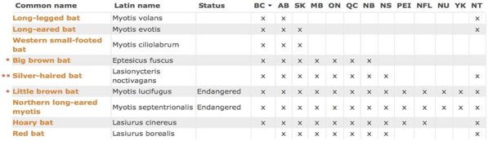
The BNA is comprised of varying landscapes: grassland, riparian, and forested. Each landscape houses different organisms, thus providing an area with a broad range of biodiversity. Amongst these landscape types, are several bat species present at the BNA: Little Brown Myotis, Big Brown Bat, Silver-Haired Bat (Lasionycteris noctivagans), and Hoary Bat (Lasiurus cinereus). These species have been confirmed in the area through acoustic and/or occupancy monitoring (Low, 2017). The Little Brown Myotis can be found foraging in both forested and open landscapes near bodies of water, and are known for summer-roosting in both forest and man-made structures, such as bat houses (Coleman et al., 2014). Additionally, since they have been one of the most common insectivorous bat species found in North America until recently, they would likely be prevalent in all BNA landscape types (Coleman et al., 2014). Big Brown Bats can also be found in bat houses during the summer-roosting period, making them another common species found within the BNA (Low, 2017). Although Hoary Bats are not known to roost in bat houses, they tend to roost in the foliage of trees, most often seen congregating near the outer edge of a tree’s crown (Alberta Community Bat Program, 2018b). Silver-Haired Bats are found most often in open landscapes, such as in clear-cuts (Patriquin, & Barclay, 2003), thus their presence would be expected to be more common in the grassland and riparian landscapes of BNA. The BNA is also home to a very dense population of mosquitoes, due to the area being surrounded by water bodies. Thus, reducing mosquito populations is very beneficial to anyone whom visits or works in the area. Moreover, the BNA offers a wide variety of habitats to support these important organisms and collecting bat occupancy data is important to determine activity trends and yearly variations. This information can then be used to better inform management decisions about the various threats that North American bat species face such as WNS and habitat alteration.
Although there are several threats that affect bat populations, there are a few ways that the public can directly help with the management of these species. The first being, building and mounting a bat house and then participating in ongoing monitoring to determine if the house is occupied. Monitoring includes recording the date, location, and status of the roost at the time of sighting and conducting emergence counts from the roost during the summer months (Alberta Community Bat Program, 2018a). Lastly, recording any sightings of bats seen flying or roosting on or around anthropogenic structures can also contribute to the monitoring efforts being conducted in Alberta (Alberta Community Bat Program, 2018a). This is why it is important to not only build bat houses, but also to monitor them. Through conducting occupancy monitoring within known roosting locations, as our study entails, we can monitor population trends by comparing the data obtained throughout the years and assessing yearly fluctuations. Monitoring bat activity within the BNA is important to determine which species inhabit the area as well as which habitats are important for bats. Bat monitoring also helps to determine the health of the environment as they are biodiversity indicator species (Bat Conservation Trust, 2018).
The purpose of our study is to monitor the varying rates of bat house occupancy within the BNA in relation to house size, habitat type, and time of year. We hypothesize that the bigger bat houses will be more occupied than the smaller designs. We also predict that the houses located in the interior habitat, as opposed to open and edge habitats, will be more frequently occupied.
Methods
Study Area
The Beaverhill Bird Observatory (BBO) is located within the BNA near Tofield, Alberta. (Figure 1). The area is constituted of forested, riparian, and grassland habitats, dominated by trembling aspen (Populus tremuloides), willow (Salix sp.), grasses, rushes, and balsam poplar (Populus balsamifera). There are 27 bat houses being monitored weekly. The majority of the houses are located within the forested and grassland habitats. The natural area is only accessible by foot; ATVs and vehicles are not permitted within the Natural Area boundaries for conservation purposes.

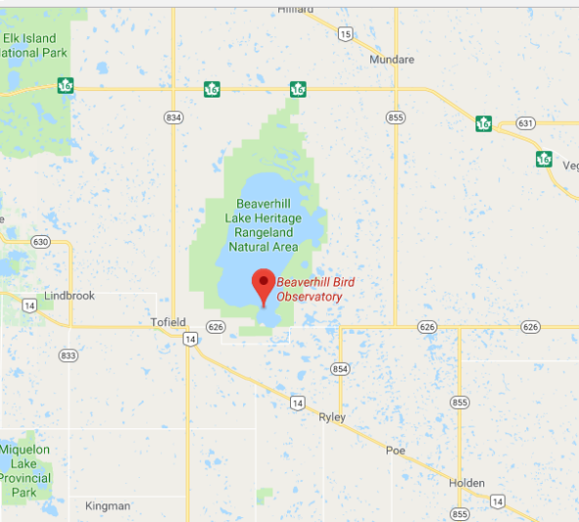
Figure 1. A map generated by Google Maps showing the location of the Beaverhill Bird Observatory in relation to Tofield. (Retrieved from: https://www.google.ca/maps/place/Beaverhill+Bird+Observatory/@53.3805631,-113.0876912,9z/data=!4m5!3m4!1s0x53a078ee20cbe307:0xcf0ce60539737e95!8m2!3d53.3805599!4d-112.5273885)

Bat House Occupancy Monitoring
Over the course of nineteen weeks, a total of 27 various-sized bat houses surrounding the BBO, within the BNA were monitored for occupancy (Figure 2). The houses were monitored weekly to ensure consistent data collection. A weekly survey consisted of walking a designated route to each house and glimpsing inside with a flashlight to determine whether it was occupied or not (Figure 3 & Figure 4). The date, start and end temperatures, house number, occupancy status, number of bats, and possible species were documented on data sheets for every house during a survey (Appendix A). Each survey would take approximately 60 minutes. It should be noted that due to unsafe weather conditions during the third week of July, data collection did not occur. Bat houses 2, 4, and 5 were omitted during this study; these are not included in the 27 bat houses that were monitored all season. The trail leading to house 2 was closed to prevent disturbing an active Northern Saw-Whet Owl nest, and houses 4 and 5 were later omitted due to their distance from the other houses and because they were found to be consistently unoccupied (Figure 2). Bat houses 8, 17, 19, 22, 24, 28, 31, 34 were removed on August 11, 2018 by Geoff Holroyd and given as a donation to the BBO’s Young Ornithologists program’s members. These small-style bat houses were chosen as donation candidates due to them being unoccupied throughout the entire monitoring season. Bat houses 4, 10, 20, 27, 32, and 39 were also unoccupied throughout the season but still remain mounted in the area.

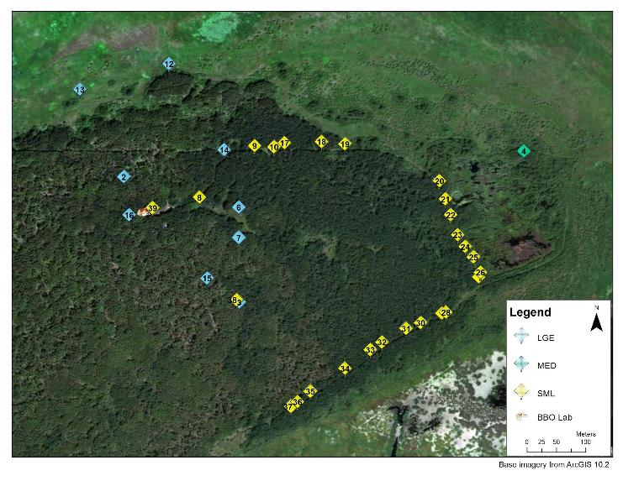
Figure 2. ArcGIS-generated image of the bat house locations and sizes. (L. Burns, 2018).

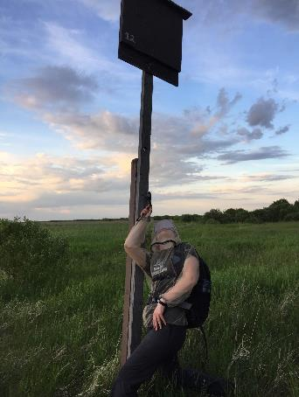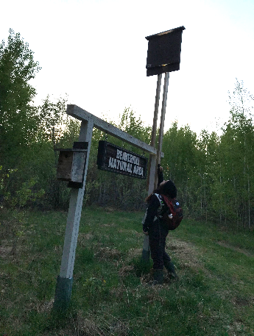
Figure 3. Monitoring occupancy at bat house 12 (left) and 14 (right) by briefly shining the flashlight into the bottom of the suspended house. (V. Caron (right) & J. Hlewka (left), 2018).

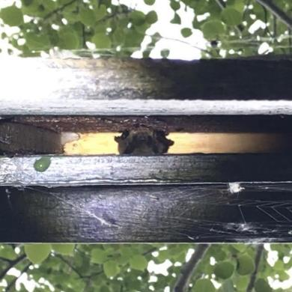
Figure 4. Solitary occupancy of bat house 6 by a Myotis species (J. Hlewka, 2018).

Bat House Locations and Descriptions
The bat houses within the BNA are located within three different habitat types: open habitat, interior habitat, and edge habitat. The open habitat consists of an open grass field with minimal shrub and tree cover; the interior habitat is dominated by dense young aspen and poplar species; and the edge habitat is located along Flicker Freeway, a frequently-travelled cleared trail located between the forest and the weir (Figure 6). Within these habitats, two different sizes of single-chambered bat houses are depicted: large and small-style bat houses (Appendix B). The data for the measurements and observations for each bat house were taken from last year’s survey, with the permission of Erin Low, the author and our internship mentor.

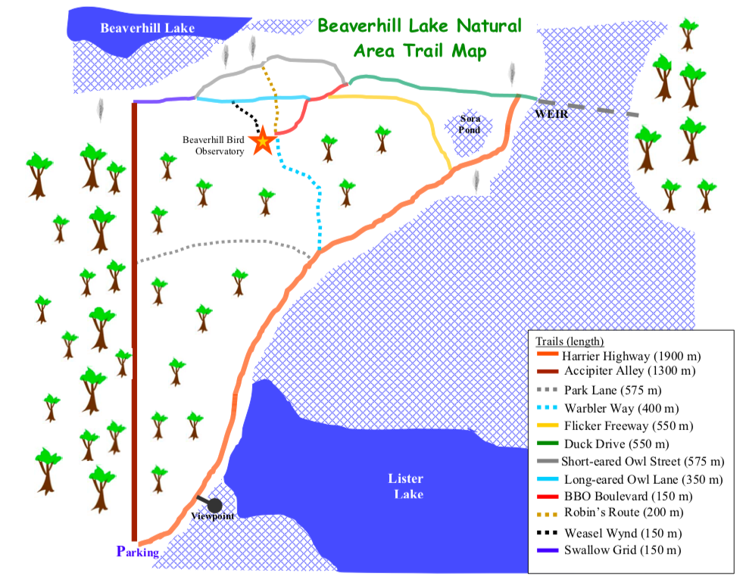
Figure 6. BNA Trail Map (Retrieved from: http://beaverhillbirds.com/directions/).

Statistical Analysis
A Mann-Whitney U-Test was conducted to determine the difference in occupancy between the bat house sizes (small and large) and a Kruskal-Wallis test was conducted to determine the difference in occupancy between habitat types (open habitat, edge habitat, and interior habitat). The statistical analysis was conducted in accordance to last year’s monitoring report, written by Erin Low, in order to compare the data from year to year (Low, 2017).

Results
Bat House Occupancy
Over the nineteen weeks of study, a total of 131 occupancies were recorded from the 27 bat houses that were surveyed; 25 more occupancies were recorded compared to last year’s data (Low, 2017). The highest number of occupancies in relation to house size occurred within large houses (97 bats) in comparison to the small houses (34 bats) (Figure 7 & 8). When looking at occupancy with respect to habitat type, the highest number of occupancies occurred within the interior habitat (104 bats), followed by the edge habitat (16 bats), and then open habitat (11 bats) (Figure 9). Additionally, most of the occupancies occurred during August (71 bats), followed by July (30 bats), June (17 bats), May (12 bats), and September (1 bat) (Figure 7). It should be again noted that bat house 2 was not monitored due to the trail leading to it being closed for the season, and house 4 was not monitored due to its distance from the other bat houses. Bat houses 8, 17, 19, 22, 24, 28, 31, and 34 were removed mid-season as a donation to the Young Ornithologists program at BBO (Appendix B).

Statistical Analysis
In order to determine if there is a mean difference in occupancy between house sizes and habitat types, we conducted two nonparametric statistical analyses: a Mann-Whitney U-Test to determine the difference in occupancy in relation to the two house sizes, and a Kruskal-Wallis test to determine the difference in occupancy in relation to the three habitat types. Our null hypothesis is that there is no significant mean difference in occupancy between house sizes and habitat types; our alternate hypothesis is that there is a significant mean difference between house sizes and habitat types. Upon completion of the statistical analysis for bat house sizes, our U value (7.5) was greater than the Mann-Whitney U-Test table value of 1; thus, we fail to reject the null hypothesis and no further statistical analysis is required. When analyzing our data for bat house habitat types, our K value (0.9675) for the Kruskal-Wallis test was smaller than the table value of 5.99; thus, we fail to reject the null hypothesis and no further statistical analysis is required. This suggests that there is no difference in occupancy between the different bat house sizes and habitat types.
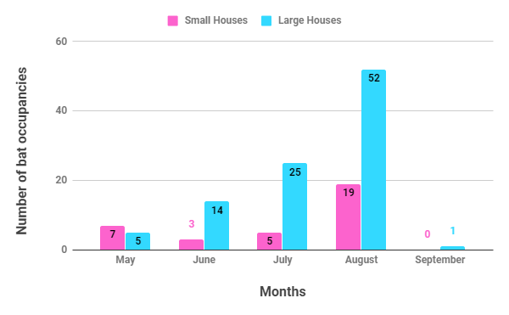
Figure 7. The number of bat occupancies in small and large bat houses over a period of nineteen weeks at the Beaverhill Bird Observatory.
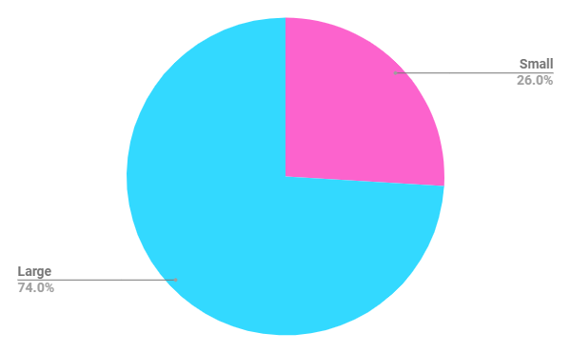
Figure 8. The difference in occupancy between small and large bat houses over a period of nineteen weeks at the Beaverhill Bird Observatory.

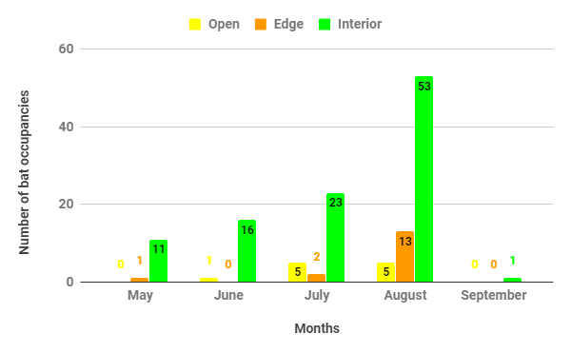
Figure 9. The number of bat occupancies in bat houses located in interior, edge, and open habitats over a period of nineteen weeks at the Beaverhill Bird Observatory
Additional Occupancies
Although we were not actively monitoring the new maternity roosts that were installed in August 2018, we did record a solitary Myotis occupancy in the maternity roost closest to the BBO laboratory on August 9, 2018.

Discussion
The occupancy data that were analyzed supported our null hypothesis. Statistical analysis showed that there was no significant difference in the occupancy between house sizes or habitat types. The limited statistical differences could be affiliated with several extrinsic factors such as the extent of our sample size and the unequal distribution of house sizes within each habitat type. Additionally, unequal distribution of houses within habitat types could have attributed to the limited statistical differences and/or skewed data. However, roosting preference was generally seen to be associated to the larger houses and the interior habitats.

A variable that could have affected our results is the fact that some of the bat houses could not be monitored due to several factors. Bat house 2 could not be monitored due to the closure of Weasel Wynd, to prevent disturbing a nesting Northern Saw-Whet Owl. This house could have potentially been occupied due it being located in the interior habitat and it being a large bat house. Based on our data, those two factors have contributed to the most occupancies throughout the nineteen-week monitoring period. Eight other bat houses could not be monitored as of August 11, 2018. Although these specific bat houses were chosen for removal due to there being no occupancies recorded in those houses in the monitoring seasons of 2017 and 2018, this does not eliminate the possibility of recording occasional occupancies in the future.

An additional variable that could have affected occupancy is the habitat type in which the bat house was located. Based on the data, it appears that bats generally preferred bat houses located within the interior habitat, as opposed to the edge and open habitats. A study conducted in 2017 by Pauli et al. achieved similar results when looking at the occupancy of bats from the Myotis genus in various forested and non-forested habitats. They determined that species from the genus Myotis prefer younger forested habitats as opposed to old-growth forests, and they preferred young forests surrounded by open habitats (Pauli et al.,2017). This is consistent with our results as we observed higher occupancy levels in interior forested habitats, and the forests surrounding the BNA are young, fragmented, and surrounded by open habitats.

The bat house size difference could have affected the results obtained in this study. Our data showed a clear roosting preference in favor of larger houses when compared to smaller ones. A study conducted by Hoeh et al. in 2018 came to a similar conclusion in that bats were more likely to roost within a larger house, specifically the rocket box style (Hoeh et al., 2018). Although the houses in our study were only single chamber roosting houses, the correlation between roosting preference and bat house size can still be made.

A factor that could have contributed to the results in terms of the preferences observed towards larger interior houses were forest and anthropogenic disturbances. The beaver colony established on a nearby waterbody and the proximity of bat houses to man-made trails were the two disturbance types. Throughout the study, numerous trees within the edge habitat were felled by beavers as well as wind storms, resulting in habitat disturbances within close proximity of the bat houses being surveyed. Disturbance, whether anthropological or natural, directly affects the roost selection of bats (Kunz, 1982 as mentioned in Lewis, 1995). This disturbance could have directly influenced the amount and habitat type in which the bats were choosing to roost. Characteristics of roosting behaviour can also be directly influenced by humans (Kunz, 1995). Due to the survey area being located within the BNA, anthropogenic influences were limited, but still present. In relation to the surveying of the bat houses, the majority of houses surveyed were located within the edge habitat, which is located on the perimeter of a man-made trail. Although the only disturbance would be that of foot traffic and trail maintenance, this could still have resulted in variability in roost and habitat selection of the bats.

Conclusion
Throughout the nineteen-week period, we recorded a total of 131 bat occupancies within the BNA; thus, we recorded 25 more occupancies than last year. Peak bat occupancy occurred in mid-August and dramatically decreased from then on until the conclusion of our study. We failed to reject our null hypotheses and thus determined that there was no significant mean difference in occupancy between the two bat house sizes and the three habitat types. Our results show that the larger-style houses are more frequently-occupied than the smaller ones; however, this was not statistically-significant. We also determined that bats tended to prefer the houses located in the interior habitat but, upon data analysis, this was concluded not statistically-significant.

Future Recommendations
Since larger houses and interior habitats were generally preferred, any new houses placed in the area should be of the larger-style and located in the interior habitat to increase the chances of occupancy. Another suggestion would be to add bat houses within the open habitat type, due to it having least amount of bat houses installed; this could determine if the unequal sample sizes are skewing the data. Future statistical analysis could be done proportionally as an occupancy percentage for each bat house style and habitat type, as the unequal distribution of bat house styles and habitat types may be skewing the data. Additionally, the maternity roost-style houses that were installed in late August should be numbered and monitored next season. This new style of house could possibly increase the number of occupancies observed within the BNA, and weekly monitoring should continue in future years.

Acknowledgements
We would like to thank the Beaverhill Bird Observatory staff for providing us with the opportunity to be a part of this wonderful project. We would also like to give thanks to Geoff Holroyd, Laurie Hunt, and the Fort Saskatchewan Naturalist Society for organizing the internship, as well as the Serving Communities Internship Program (SCiP) for the funding towards our project. We are so grateful for all the support and help we have had from our project mentor, Erin Low; thank you for lending us equipment and helping with everything we needed throughout our project, we could not have done it without you. We would also like to thank Ken and Laurie Hlewka for providing us their vehicles for travelling to the field site every week and to Lynne Burns for volunteering her time to assist us with our project, and for generating an ArcGIS map for our project. Lastly, we would also like to thank Dave Critchley for supporting us throughout our project and for answering any additional questions we have had.

References
Alberta Community Bat Program (2018a). Building and installing a bat house. Retrieved from: http://www.albertabats.ca/bathouses/
Alberta Community Bat Program (2018b). Building bat-friendly Communities: Alberta program guide. Retrieved from: http://www.albertabats.ca/resources/
Bat Conservation International (2018). Why bats?: Bats are important. Retrieved from: http://www.batcon.org/why-bats/bats-are/bats-are-important
Bat Conservation Trust (2018). Why bats matter. Retrieved from: http://www.bats.org.uk/pages/why_bats_matter.html
Bartonička, T. & Řehák, Z. (2007). Influence of the microclimate of bat boxes on their occupation by the soprano pipistrelle Pipistrellus pygmaeus: Possible cause of roost switching. Acta Chiropterologica 9(2), 517-526.
Barros, M. A. S., Pessoa, D. M. A., & Rui, A. M. (2014). Habitat use and seasonal activity of insectivorous bats (Mammalia: Chiroptera) in the grasslands of southern Brazil. Zoologia (Curitiba), 31(2), 153-161. doi: 10.1590/S1984-46702014000200006
Coleman, L. S., Ford, W. M., Dobony, C. A., & Britzke, E. R. (2014). Comparison of Radio-telemetric Home-Range Analysis and Acoustic Detection for Little Brown Bat Habitat Evaluation. Northeastern Naturalist, 21(3), p. 431-445.
Government of Alberta (2018). Wildlife diseases: White-nose syndrome. Retrieved from: http://aep.alberta.ca/fish-wildlife/wildlife-diseases/white-nose-syndrome/default.aspx
Hoeh, J. P. S., Bakken, G. S, Mitchell, W. A., & O’Keefe, J. M. (2018). In artificial roost comparison, bats show preference for rocket box style. PLoS One, 13(10). doi: 10.1371/journal.pone.0205701
Kunz, T. H. (1982). Ecology of bats. New York, NY: Plenum Press
Kunz, T. H., Braun de Torrez, E., Bauer, D., Lobova, T., & Fleming, T. H. (2011). Ecosystem services provided by bats. The Year in Ecology and Conservation Biology, 1223(1), p. 1-38. doi: 10.1111/j.1749-6632.2011.06004.x
Lausen, C., & Barclay, R. M. R.. (2006). Benefits of Living in a Building: Big Brown Bats (Eptesicus fuscus) in Rocks versus Buildings. Journal of Mammalogy, 87(2), 362-370
Lewis, S. E. (1995). Roost fidelity of bats: A review. Journal of Mammalogy, 76(2), 481-496.
Low, E. (2017). Occupancy monitoring of bat houses at beaverhill bird observatory in 2017. Beaverhill Birds. Retrieved from: http://beaverhillbirds.com/publications/student-interns/
Neighbourhood Bat Watch (2018). Learn about bats: White-nose syndrome. Retrieved from: https://batwatch.ca/content/white-nose-syndrome
Patriquin, K. J., & Barclay, R. M. R. (2003). Foraging by Bats in Cleared, Thinned and Unharvested Boreal Forest. Journal of Applied Ecology, 40(4), p. 646-657.
Pauli, B. P., Zollner, P. A., & Haulton, G. S. (2017). Nocturnal habitat selection of bats using occupancy models. Journal of Wildlife Management, 81(5), p. 878-891. doi: 10.1002/jwmg.21251
Reichard, J. D., & Kunz, T. H. (2009). White-nose syndrome inflicts lasting injuries to the wings of little brown myotis (Myotis lucifugus). Acta Chiropterologica, 11(2), 457-464. doi: 10.3161/150811009X485684
Tuttle, M. D. (1979). Status, causes of decline, and management of endangered gray bats. The Journal of Wildlife Management, 43(1), 1–17.
Verant, M. L., Boyles, J. G., Waldrep Jr., W., Wibbelt, G., & Blehert, G. S. (2012). Temperature-dependent growth of geomyces destructans, the fungus that causes bat white-nose syndrome. PLoS One, 7(9). doi: 10.1371/journal.pone.0046280

Appendix A - Field Data Sheets

Beaverhill Bird Observatory Bat House Occupancy Check Data Sheet (2018)

Survey Date:

Personnel Present:

Start Time: | Start Temperature:
End Time: | End Temperature:

Bat House # | Time Checked | # Bats Present | Suspected Species | Comments
Appendix B - Bat House Locations and Descriptions

Bat House ID | Size | Attachment | Colour | Inside Painted? | Habitat Type | Direction | Sunlight exposure
*19 | small | tree (aspen) | red | yes | edge | south | mostly shade (minor sun)
18 | small | tree (aspen) | red | yes | edge | south | partial sun (only morning or afternoon sun)
*17 | small | tree (aspen) | red | no | edge | southwest | mostly shade (minor sun)
10 | small | tree (aspen) | red | yes | interior | south | partial sun (only morning or afternoon sun)
9 | small | tree (aspen) | red | yes | interior | south | partial sun (only morning or afternoon sun)
14 | large | post | brown | no | interior | southeast | mostly sunny (minor shade)
6 | large | tree (aspen) | green | no | interior | west | mostly sunny (minor shade)
7 | large | tree (aspen) | green | no | interior | southwest | mostly shade (minor sun)
15 | large | tree (balsam) | brown | no | interior | southwest | partial sun (only morning or afternoon sun)
16 | large | tree (balsam) | brown | no | interior | southeast | partial sun (only morning or afternoon sun)
11 | large | tree (aspen) | brown | no | interior | south | mostly sunny (minor shade)
39 | small | tree (aspen) | red | lightly painted | interior | south | mostly sunny (minor shade)
13 | large | post | brown | no | open | southwest | full sun (no shade)
12 | large | post | brown | no | open | southwest | full sun (no shade)
**2 | large | tree (balsam) | green | no | interior | southeast | partial sun (only morning or afternoon sun)
3 | large | tree (balsam) | green | no | interior | east | mostly shade (minor sun)
38 | small | tree (balsam) | red | lightly painted | interior | east | mostly shade (minor sun)
37 | small | tree (aspen) | red | yes | interior | southeast | partial sun (only morning or afternoon sun)
36 | small | tree (aspen) | red | no | interior | southeast | mostly shade (minor sun)
Bat House ID | Size | Attachment | Colour | Inside Painted? | Habitat Type | Direction | Sunlight exposure
35 | small | tree (aspen) | red | yes | edge | south | partial sun (only morning or afternoon sun)
*34 | small | tree (aspen) | red | yes | edge | southeast | mostly shade (minor sun)
33 | small | tree (aspen) | red | lightly painted | edge | southeast | partial sun (only morning or afternoon sun)
32 | small | tree (aspen) | red | no | edge | southeast | partial sun (only morning or afternoon sun)
*31 | small | tree (aspen) | red | no | edge | southeast | mostly shade (minor sun)
30 | small | tree (aspen) | red | yes | edge | southeast | mostly shade (minor sun)
29 | small | tree (aspen) | red | no | edge | southeast | mostly shade (minor sun)
*28 | small | tree (aspen) | red | yes | edge | southeast | mostly shade (minor sun)
27 | small | tree (aspen) | red | yes | edge | southeast | partial sun (only morning or afternoon sun)
26 | small | tree (aspen) | red | yes | edge | south | mostly shade (minor sun)
25 | small | tree (aspen) | red | yes | edge | southwest | partial sun (only morning or afternoon sun)
*24 | small | tree (aspen) | red | yes | edge | south | mostly shade (minor sun)
23 | small | tree (aspen) | red | yes | edge | south | partial sun (only morning or afternoon sun)
*22 | small | tree (aspen) | red | yes | edge | southeast | mostly shade (minor sun)
21 | small | tree (aspen) | red | yes | edge | south | partial sun (only morning or afternoon sun)
20 | small | tree (aspen) | red | yes | edge | southwest | partial sun (only morning or afternoon sun)
**4 | medium | tree (aspen) | brown | yes | interior | south | full shade (no direct sun)
*8 | small | tree (aspen) | red | no | interior | southeast | mostly shade (minor sun)
BBO station | building | building | red | yes | interior | south | mostly sunny (minor shade)
(Houses with asterisks were removed as a donation to the Young Ornithologists program at the BBO on August 11, 2018; houses with two asterisks were omitted due to nesting Northern Saw-Whet Owls (house 2) and no recorded occupancies the year prior (house 4))

