Beaverhill Bird Observatory
Weekly Update August 18-24th
This week Christmas came early for the BBO staff. Almost every morning, staff were delighted to find a surprise within the mist nets. Such gifts include; 7 Canada Warblers, a Boreal Chickadee, 2 Merlins, and a Townsends Warbler! Staff like to believe this spike in uncommon bird captures was due to their very cool sunglasses adorned throughout banding. This week Jeremy also spotted a lost baby coot waddling down BBO Boulevard. Luckily, staff and volunteers reunited it with it’s coot kin at the weir.
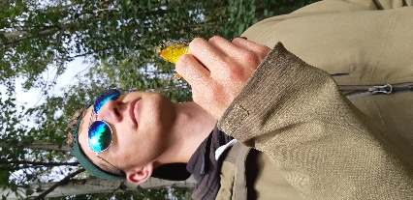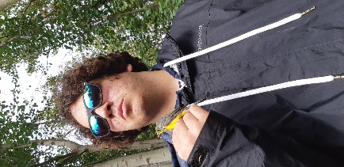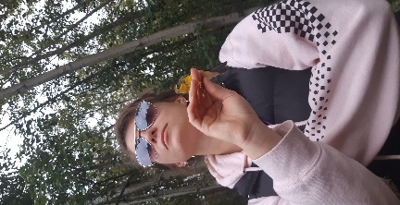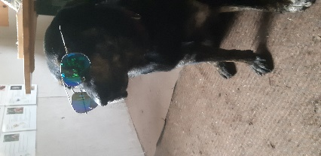
Staff and Volunteers proudly showing off a Canada Warbler.
Two Merlins were found waiting within one of our mist nets, to the delight of Jeremy and Jon Van Arragon (volunteer). Once brought to the lab, excitement exploded from all staff and volunteers, as we looked up and pulled out an appropriate sized band. Upon closer examination of these majestic accipiters, we discovered that one of them still had breakfast on its beak!
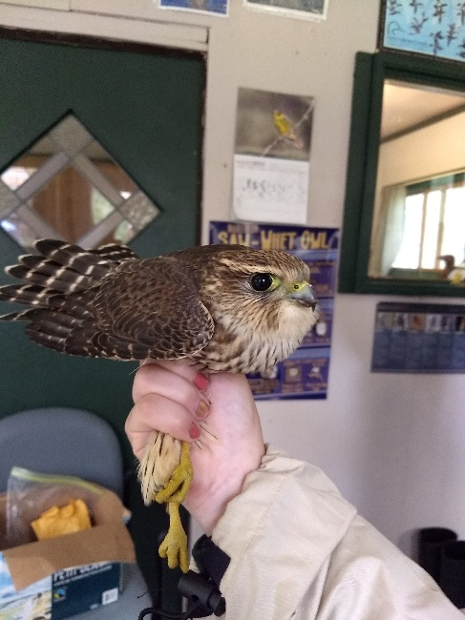
For the first time in BBO history, a Townsends Warbler has been banded! Staff were at first perplexed, but eventually settled on the identification. Townsend Warblers are typically found further west along the Rocky Mountains with their range extended to the west coast. It was truly a treat to band such a beautiful bird in the prairies!
Large birds have also been spotted on migration this week, including a couple species of herons. At the weir, upwards of 30 Black-crowned Night Herons were spotted and 2 Great-Blue Herons. Adults and juveniles of both species happily barked amongst themselves as they flew from cattail to cattail devouring prey.
With addition to the fruitful banding, staff kept busy completing office tasks. Sara was especially busy completing office work before owl season kicks-off, starting in September. Other staff completed climate change blog posts, responded to e-mails, finished MAPS data entry, and worked on reports. Jeremy has also been working on his Northern Saw-Whet owl paper.
A Merlin
The BBO would like to thank all of our volunteers, board members, visitors and interns for their continual support. We would particularly like to thank; Tessa Frisky, Melissa Chisholm, Jon Van Arragon, Irene Crosland, Geoff Holroyd and Laurie Hunt for visiting and helping staff out! Their hard work is definitely appreciated!

A Black-capped Chickadee & a Boreal Owl

Table 1: Summary of Fall Migration Monitoring for Aug. 18th -24th.
Species | Banded | Repeat¹ | Return² | Foreign³ | Other⁴ | Total
American Goldfinch | 1 |  |  |  |  | 1
American Redstart | 16 | 1 |  |  |  | 17
Blackpoll Warbler | 4 |  |  |  |  | 4
Blk.-capped Chickadee | 6 | 8 | 3 |  | 2 | 19
Blue-headed Chickadee | 1 |  |  |  |  | 1
Boreal Chickadee | 1 |  |  |  |  | 1
Canada Warbler | 7 |  |  |  |  | 7
Cedar Waxwing | 1 |  |  |  |  | 1
Clay-Colored Sparrow | 3 |  |  |  |  | 3
Common Yellowthroat | 2 |  |  |  |  | 2
Grey Catbird | 1 |  |  |  |  | 1
House Wren | 2 |  |  |  |  | 2
Least Flycatcher | 15 | 2 |  |  | 2 | 19
Magnolia Warbler | 5 | 2 |  |  |  | 7
Merlin | 2 |  |  |  |  | 2
Mourning Warbler | 1 |  |  |  |  | 1
Northern Waterthrush | 1 |  |  |  |  | 1
Ovenbird | 11 |  |  |  |  | 11
Red-breasted Nuthatch | 6 | 1 |  |  |  | 7
Sparrow Spp. |  |  |  |  | 1 | 1
Tennessee Warbler | 21 | 3 |  |  | 1 | 25
Townsend Warbler | 1 |  |  |  |  | 1
Unid. Trail’s Flycatcher | 4 |  |  |  |  | 4
Warbling Vireo | 2 | 2 | 1 |  | 1 | 6
Wilson’s Warbler | 1 |  |  |  |  | 1
Yellow Warbler | 20 |  |  |  |  | 20
Yellow-bellied Flycatcher | 1 |  |  |  |  | 1
Total | 141 | 19 | 4 | 0 | 7 | 166
1 Banded recently (within 90 days) at the BBO
2 Banded at the BBO >90 days prior to recapture (e.g. in a previous year).
3 Banded at a location other than the BBO
4 Caught in a mist-net but not banded (e.g. escaped net).
Net Hours: 502.5
Capture Rate: 34.03/100 hrs

