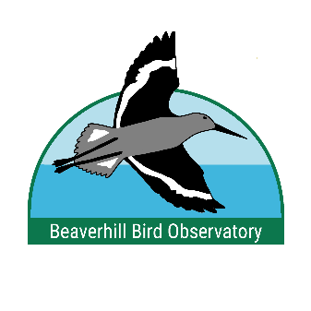
Young Ornithologists Workshop

The Beaverhill Bird Observatory’s Geoff Holroyd’s Young Ornithologists Workshop is a week-long experience that provide teenagers interested in nature with a practical, working knowledge and aesthetic appreciation of birds and their conservation. The workshop will run from Monday, July 31st to Sunday, August 6th, 2023. Up to ten participants, aged 15-18 years old, will be selected. Each morning the youth will be provided with the opportunity to learn bird banding and identification skills from experienced ornithologists at our field research station located east of Tofield, Alberta. In the afternoons they will be introduced to a variety of wildlife topics from local experts. Applicants do not have to be experienced birders, but they should have an interest in nature, birds and conservation. The BBO will cover all direct costs of the workshop including food, travel for field trips, and professional instruction. Recipients are responsible for their transportation to and from the banding station, tents, sleeping mats and sleeping bags. Tents and mats are available for loan if applicants cannot bring their own.

Participants will be immersed in the daily, hands on work of field ornithology while they learn about the BBO’s Migration Monitoring program and MAPS (Monitoring Avian Productivity and Survivorship) sites and participate in the running of a banding station. They will improve their bird identification while being trained in the skills and art of handling and banding birds, aging and sexing techniques, bird behaviour and the life histories and conservation concerns of species. The students will also learn about bats, butterflies, raptors and other wildlife. The students will be tenting and sharing camp duties, necessary skills for a field biologist. Field trips to surrounding areas and talks by experts on natural history topics will be offered in the afternoons and evenings.

Geoff Holroyd is the current Chair of the BBO and a co-founder of the BBO, the oldest bird observatory in Alberta and second oldest in Canada. Geoff relates how times spent as a youth at Long Point Bird Observatory were instrumental in developing his birding skills and commitment to working with birds as a career. It is the goal of the BBO to continue in this tradition and offer interested youth the opportunity to advance their birding skills while learning about birds and other wildlife in a field situation.

The Application below should be sent to helentrefry@gmail.com .

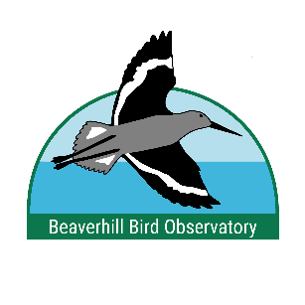
GEOFF HOLROYD
YOUNG ORNITHOLOGISTS WORKSHOP
APPLICATION FORM

Please return this application and all necessary attachments to:
helentrefry@gmail.com (scan and email) or mail hard copies to
Helen Trefry, 20102 Twp Road 512, Beaver County, AB T0B 4J1.
Applications must be received by July 1st, 2023.

Name: ________________________________________________________

Birth Date: _____________________________________________________

Mailing Address: ________________________________________________

_____________________________________________________________

Home Phone: _________________ Applicant’s Cell: ___________________

Applicant’s Email: ________________________________________________

How many species of Canadian birds are you able to identify (circle one)?

30-50 51-75 76-100 101-125 >125

At what age did you become interested in birds and natural history?
________________________________________________________________

Do you have any other hobbies or sports that you like to participate in? What are they?
________________________________________________________________
________________________________________________________________
________________________________________________________________Do you have camping experience? If so, explain the extent of your experience.
________________________________________________________________
________________________________________________________________
________________________________________________________________
List any natural history clubs or organizations you belong to and how long you have been a member.
________________________________________________________________
________________________________________________________________

BBO strives for equal opportunity learning experiences. If you wish to share the diversity you would bring to this Workshop please indicate your ethnicity:________________________

How would you evaluate your physical health? (circle one):
Fair Good Excellent

List any allergies you have (please include environmental, food and drug allergies):
________________________________________________________________
________________________________________________________________

Are there any foods that you avoid for health or allergy reasons?
________________________________________________________________________________________________________________________________
On a separate page(s), please attach the following:

- A paragraph about why you want to participate in this workshop.

- A paragraph telling us why you think birds, and wilderness in general, are important to conserve.

Parents of successful applicants will be required to sign a release form before the applicant can attend.

Parents'/Guardians' Name(s): ________________________________________

Phone number(s) where parents/guardians can be reached:

Home: ________________________________
Cell: ________________________________

Parent’s email contact: ________________________________

Please attach a letter of support from one adult reference (for example a teacher, scout leader, head of naturalist club). This letter should attest to your natural history interest and skills, as well as your ability to work as part of a team in a camping situation. The letter of support needs to include the following:

Name of Reference: _______________________________________________

Position:_________________________________________________________

Relationship to you:________________________________________________

Address:_________________________________________________________

________________________________________________________________

Phone Number (s): _________________________________________________

