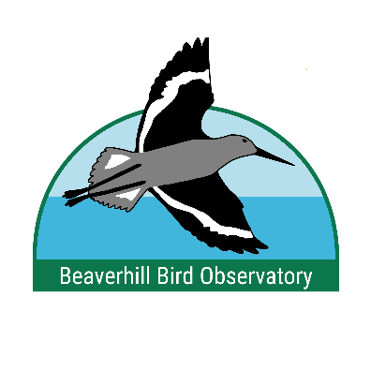
Beaverhill Bird Observatory’s
BirdSmart Education Program

Kindergarten and younger are booked for 30 minutes; all others are booked for 60 minutes
Book multiple presentations on the same day to receive a 10% discount!
See BirdSmart pamphlet or website for topic and pricing information

Please fill in the following booking request
School name (or group name):
Complete address:
Contact name:
Email address:
Phone number:
Do you have a projector or smartboard?
Preferred Date(s):
Alternate date(s):
In-person or virtual:
Number of presentations requested:

We can accommodate up to 4 presentations per day. Please fill out the following section for each presentation requested.
Please note that Falcons of Alberta, Hawks of Alberta, Owls of Alberta, and Raptors of Alberta may be booked based on ambassador bird availability.

Preferred time(s):
Topic:
Grade level (or age group):
Class/group size:

Preferred time(s):
Topic:
Grade level (or age group):
Class/group size:

Preferred time(s):
Topic:
Grade level (or age group):
Class/group size:

Preferred time(s):
Topic:
Grade level (or age group):
Class/group size:

